5x7 Display SCREEN EFFECTS
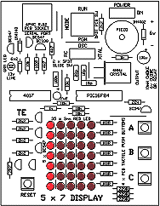
Shown below are some of the effects you can get on the 5x7 Display. Some are much longer and more complex, but since the gif files take up so much memory, they have been shortened to save down-loading time. The "Lift Display" for example, has both up and down scrolling as well as floors "G" to 9.
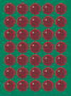 Experiment 1 - Illuminating a LED
Experiment 2 - Flashing a LED
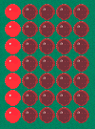 Experiment 9 - Running a LED Across/Back, Up/Down
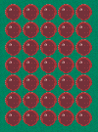 Experiment 11 - Elevator Display -"Lift Display"
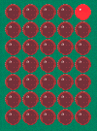 Experiment 12 - TE Moving (or RUNNING) Sign
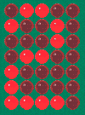 Experiment 14 - Two Digit Up Counter
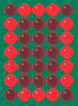 Experiment 15 - Five Digit Up Counter

