5x7 Display Testing
TESTING THE DISPLAY
When all the components have been fitted, the LED display should be tested to make sure all the LEDs are working.
The first test is an electrical test to make sure each of the LEDs illuminates and has the correct brightness.
For this you will need a very simple piece of TEST GEAR.
It is a 470R resistor connected to the positive lead of a battery snap and a stiff piece of wire (cut from a resistor) soldered to the other lead. These leads are now called PROBES.
Place the positive probe on one of the 100R resistors on the PC board and the negative probe on one of the collector of the first transistor. One of the LEDs should illuminate. Try each of the 100R resistors and each of the LEDs in a column should illuminate.
Repeat with the collector of the other transistors.
Replace any faulty or weak LEDs as the display must have uniform brightness.
There are 3 possible causes for a LED not to illuminate.
1. Dry joints on the underside of the board,
2. LED fitted around the wrong way, and
3. Your soldering-time is too long or the soldering iron is too. LEDs can easily be damaged by excessive heat and this will cause their brightness to be reduced. Use a small soldering iron (preferable a temperature-controlled iron and keep the tip clean. Only use fresh solder for each joint and this will keep the soldering time to a minimum.
DRIVING THE DISPLAY
We will now test the display with a number of TEST PROGRAMS in the PIC chip.
The first Test Program is called TEST1.
A jumper must be soldered between the collector and emitter of the first transistor so that all the LEDs will illuminate when the output lines of the PIC chip go HIGH.
Test1 will make the first column of LEDs flash at 3Hz.
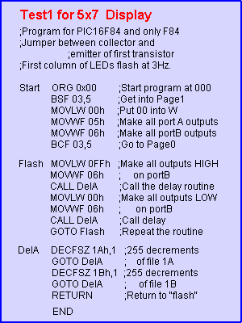
The block of numbers below is the HEX file for Test 1. Copy and paste it into a text program such as TEXTPAD or NOTEPAD and call it: Tst1-5x7.hex

:1000000083160030850086008312FF3086000C20A6
:10001000003086000C2005289A0B0C289B0B0C281E
:020020000800D6
:00000001FF
Test2 checks to see that each LED is wired in the correct order. The delay is 1Hz:
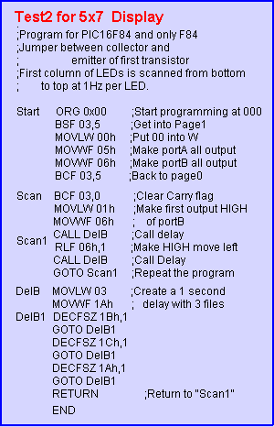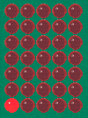
The block of numbers below is the HEX file for Test 2. Copy and paste it into a text program such as TEXTPAD or NOTEPAD and call it: Tst2-5x7.hex

:1000000083160030850086008312031001308600BD
:100010000C20860D0C20092803309A009B0B0E281B
:0A0020009C0B0E289A0B0E28080016
:00000001FF
Test3 tests the 4017. The 4017 scans the columns. It has a "5-shift" and is then reset.
This program tests the outputs and makes sure the the wiring is correct. The accompanying animation shows the result of the program.
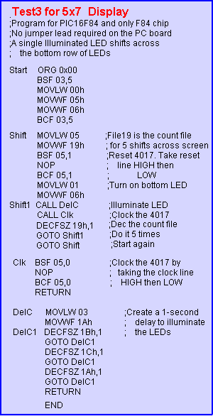
The block of numbers below is the HEX file for Test 3. Copy and paste it into a text program such as TEXTPAD or NOTEPAD and call it: Tst3-5x7.hex

:100000008316003085008600831205309900851420
:10001000000085100130860015201120990B0C2856
:100020000528051400000510080003309A009B0BFA
:0C00300017289C0B17289A0B17280800B3
:00000001FF
All the chips and the wiring has now been tested. These are the type of steps you must go through when designing a prototype, to make sure all the circuitry is correct before starting to write a program.
The next step involves writing a scan routine that takes data from 5 files and displays it on the "screen."
The five data files are called a VIRTUAL SCREEN or GHOST SCREEN. It's a programming technique that is easy to follow. Whatever is contained in the five files is displayed on the screen. That's all the routine does. Each routine is designed to do a small job. This makes the program easy to trouble-shoot, easy to understand and easy to come-back to, at a later date. It also makes it easy for others to follow.
After this we shift or change the data in the five files to produce movement on the screen.

The 5 VIRTUAL SCREEN files are: 11h, 12h, 13h, 14h, and 15h.
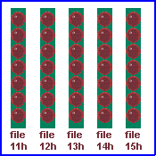
Test4 scans the LEDs slowly so you can see the scanning. To increase the scan rate so the screen appears as a "chequer-board," delete the two instructions in the delay routine.
To obtain the value for each "Ghost file," you need to know the hex value for each LED. The bottom LED has a value of 01. The next LED: 02, 04, 08, 10, 20, 40. To combine two or more LED you must add their hex values.
For instance, the two bottom LEDs have a combined value of 03. The lowest 3 LEDs have a combined value of 01 + 02 + 04 = 07. The lowest 4 LEDs: 08 + 04 + 02 + 01 = 0F
For the chequer-board effect, the values are 55h and 2Ah
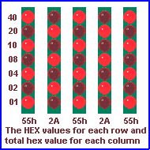.

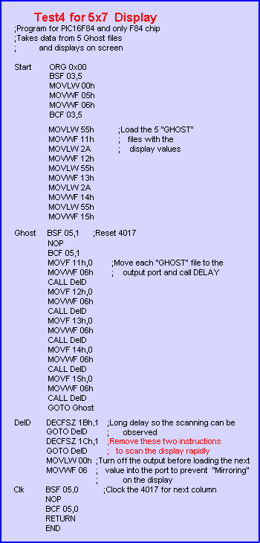

SLOW SCAN

FAST SCAN

The block of numbers below is the HEX file for Test 4. Copy and paste it into a text program such as TEXTPAD or NOTEPAD and call it: Tst4-5x7.hex

:1000000083160030850086008312553091002A3017
:100010009200553093002A30940055309500851495
:100020000000851011088600222012088600222078
:100030001308860022201408860022201508860056
:1000400022200F289B0B2228003086000514000078
:04005000051008008F
:00000001FF

RUNNING SIGN
The 5x7 Display can display running messages. Even though the "window" is only large enough for one letter to be displayed at a time, the words can still be read.
Remember, this project is just a starting point. Its concepts can be expanded to any size and shape. For the RUNNING SIGN Routine, data in table1 is loaded into 5 Ghost locations (11h, 12h, 13h, 14h, 15h) and this data is displayed on the screen. One byte is transferred at a time from the table and loaded into the Ghost section. A routine then outputs the five locations to the screen.
The data in the Ghost section is then shifted one place to the left and a new byte loaded into the 5th location (15h).
This gives the effect of a message scrolling across the screen, from right to left. The message supplied with the project is: TE MOVING SIGN, but this can be altered to any message by changing the data in Table1. To work out the value of each column of LEDs, the individual HEX values are added together.
The program looks for "FF" and repeats the message.
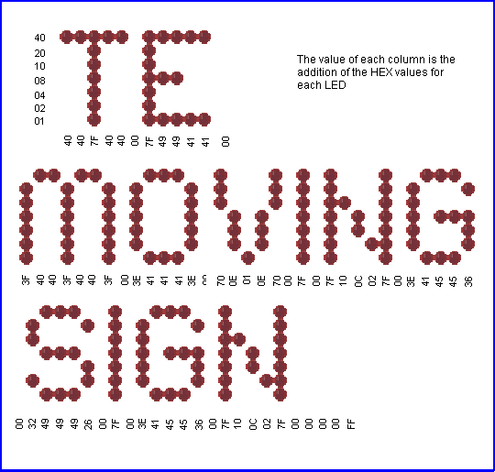

 | RUNNING SIGN for 5x7 Display  ;Program for PIC16F84 and only F84 chip  ;Takes data from Table1 and runs it across the screen  Start ORG 0x00 ;This sets up the ports  BSF 03,5  MOVLW 00h  MOVWF 05h  MOVWF 06h  BCF 03,5  GOTO Run1  ;Table1 holds the hex values for each column of LEDs  Table1 ADDWF 02h,1 ;Add W to Program Counter  RETLW 00h  RETLW 40h  RETLW 40h  RETLW 7Fh  RETLW 40h  RETLW 40h  RETLW 00h  RETLW 7Fh  RETLW 49h  RETLW 49h  RETLW 41h  RETLW 41h  RETLW 00h  RETLW 3Fh  RETLW 40h  RETLW 3Fh  RETLW 40h  RETLW 3Fh  RETLW 00h  RETLW 3Eh  RETLW 41h  RETLW 41h  RETLW 41h  RETLW 3Eh  RETLW 00h  RETLW 70h  RETLW 0Eh  RETLW 01h  RETLW 0Eh  RETLW 70h  RETLW 00h  RETLW 7Fh  RETLW 00h  RETLW 7Fh  RETLW 10h  RETLW 0Ch  RETLW 02h  RETLW 7Fh  RETLW 00h  RETLW 3Eh  RETLW 41h  RETLW 45h  RETLW 45h  RETLW 36h  RETLW 00h  RETLW 32h  RETLW 49h  RETLW 49h  RETLW 49h  RETLW 26h  RETLW 00h  RETLW 7Fh  RETLW 00h  RETLW 3Eh  RETLW 41h  RETLW 45h  RETLW 45h  RETLW 36h  RETLW 00h  RETLW 7Fh  RETLW 10h  RETLW 0Ch  RETLW 02h  RETLW 7Fh  RETLW 00h  RETLW 00h  RETLW 00h  RETLW 00h  RETLW 0FFh  Run1 CLRF 11h ;Clear the Ghost locations ready for starting  CLRF 12h  CLRF 13h  CLRF 14h  CLRF 15h  MOVLW 00  MOVWF 19h ;File 19h is the jump value for table  Run2 MOVLW 40h  MOVWF 18h ;File 18h counts the number of scans  CALL Shift ; and controls the "run speed"  INCF 19h,1  MOVF 19h,0 ;Put jump value into W  CALL Table1  MOVWF 15h ;W contains table data - put it in 15h  XORLW 0FFh ;If table value is FF,  BTFSC 03,2 ; bit 2 of file 3 will be SET (=1)  GOTO Run1 ;Start Table1 again  Run3 DECFSZ 18h,1 ;Scan the display 40h times  GOTO Run4  GOTO Run2  Run4 CALL Scan  GOTO Run3  Scan BSF 05,1 ;Reset 4017  NOP  BCF 05,1  MOVF 11h,0 ;Output the data at the 5 Ghost  MOVWF 06h ; locations to the display  CALL DelD  MOVF 12h,0  MOVWF 06h  CALL DelD  MOVF 13h,0  MOVWF 06h  CALL DelD  MOVF 14h,0  MOVWF 06h  CALL DelD  MOVF 15h,0  MOVWF 06h  CALL DelD  RETURN  ;SHIFT moves the data one place to the left to give the "movement"  ; effect on the screen  Shift MOVF 12h,0 ;Move file 12h to W  MOVWF 11h ;Move W to file 11h  MOVF 13h,0 ;Move file 13h to W  MOVWF 12h ;Move W to file 12h  MOVF 14h,0 ;Move file 14h to W  MOVWF 13h ;Move W to file 13h  MOVF 15h,0 ;Move file 15h to W  MOVWF 14h ;Move W to file 14h  RETURN  DelD DECFSZ 1Bh,1 ;Delay for viewing the  GOTO DelD ; column of LEDs  MOVLW 00h  MOVWF 06  Clk BSF 05,0 ;Clock the 4017 to  NOP ; the next output  BCF 05,0  RETURN  END | 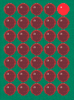

The block of numbers below is the HEX file for Running Sign. Copy and paste it into a text program such as TEXTPAD or NOTEPAD and call it: Running1.hex

:10000000831600308500860083124C288207003456
:10001000403440347F344034403400347F344934F9
:1000200049344134413400343F3440343F34403467
:100030003F3400343E344134413441343E340034A2
:1000400070340E3401340E34703400347F34003494
:100050007F3410340C3402347F3400343E34413465
:100060004534453436340034323449344934493423
:10007000263400347F3400343E3441344534453432
:10008000363400347F3410340C3402347F3400347E
:10009000003400340034FF34910192019301940143
:1000A000950100309900403098007520990A190890
:1000B00006209500FF3A03194C28980B6028532816
:1000C00062205D28851400008510110886007E20BE
:1000D000120886007E20130886007E201408860001
:1000E0007E20150886007E20080012089100130863
:1000F0009200140893001508940008009B0B7E28BA
:0C01000000308600051400000510080007
:00000001FF

ADDING PUSH-BUTTONS
Up to now, each of the programs has run as soon as the power was applied to the circuit.
In this section we add 3 push-buttons.
Push-buttons can also be called "Keys" or "input Devices" and to make sure they will be be read instantly, it is important they are "poled" (scanned) on a regular basis.
This involves putting the "Buttons" in a place where the micro is passing very often. A suitable position is inside a delay routine.
Adding push-buttons to a project gives you the capability of selecting, starting or stopping a routine as well as calling one up at any time during the running of another routine.
Writing the code for a set of push buttons can be quite complex as there are a number of things that must be taken into account, to get a push-button to work correctly.
The main problem is DEBOUNCING the button.
Suppose you are using a button to increment a number on a display. When the button is pressed, the program increments the display and returns to scan the button again. This all happens very quickly and the program thinks the button has been pushed again, so the display is incremented once more.
The micro generally goes through a routine so fast that the display can get incremented lots of times before you have time to release the button.
To prevent this from happening, the micro must look to see if the button has been released before another increment can occur.
But there's still one more feature that has to be included in the program.
When the button is pushed, the contacts make and break a number of times before finally making contact.
The micro sees this as a number of presses and the counter can be advanced a number of counts on a single press.
This also occurs when the button is being released. In some of the experiments, you can see the effect of switch-bounce by pressing and releasing the button very slowly. The counter will count more than one digit or an animation will appear on the screen two times.
To prevent this, the program must have a "loop counter" or delay so that only one count is recorded in say 1/10th of a second.
This is called fully debouncing the switch and this type of routine should be included in all programs to prevent any type of "double-counting."
The next series of programs in this test section will show how to interface a push-switch to a LED and test it.
The circuit diagram for the project is shown below so you can see how the push-buttons are connected to the microcontroller. When the button is not pressed, the input line sees a LOW. When the button is pressed, the input line sees a HIGH.
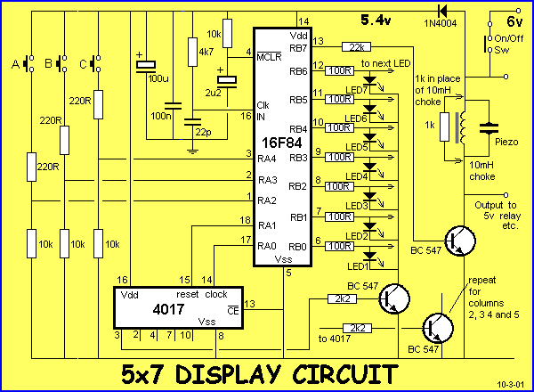
SWITCH PROGRAM-1
This program turns on a LED on the display when buttonA is pressed.
In this program there is no debouncing. The program sets up the ports with PortA as input and PortB as output. The program then loops around (poles) the switch looking for a keypress. The program then turns on a LED and loops.
There is an important point to note with the program.
For the 3rd, 4th, 5th and 6th instructions, the program is accessing a special bank of registers that are in a different part of the microcontroller to the programming and port files. We get into the "special section" via the instruction BSF 03,5 and get out of the "special section" via BCF 03,5.
The instruction on line 6: MOVLW 06h moves the "value in W" into a register called the IN/OUT CONTROL REGISTER. This register is called 06 and is not the register we call the PORT REGISTER.
The 8th instruction seems to do the same thing. BUT IT DOESN'T.
The micro has come out of page1 and is in the programming page. The programming page is Page0.
The 8th instruction takes the value in W (we put 00 into W in the 5th instruction) and put it into file 06. We call file 06 PORTB REGISTER. This time file 06 is PortB and the instruction will make all outputs of portB LOW.
The program only works once. You have to turn the power off and on again to re-test the program.

Switch-1 Program for 5x7 Display
;PIC16F84 and only F84 chip
;Detects ButtonA and illuminates a LED
Start ORG 0x00
BSF 03,5 ;Go to page1 for setting IN/OUT
MOVLW 1Ch ;Make RA2, RA3 and RA4 inputs
MOVWF 05h
MOVLW 00h ;Put 00 into W
MOVWF 06h ;Make all RB lines output
BCF 03,5 ;Go to Page0 for programming
MOVWF 06h ;Put 00 into output port to turn off all LEDs
Loop1 BTFSS 05,2 ;Test button A
GOTO Loop1 ; line is LOW
Loop2 MOVLW 01h ;Line is HIGH. Put 1 into W
MOVWF 06h ;output 1 to the display
GOTO Loop2 ;do-nothing in a loop
END

The block of numbers below is the HEX file for Switch 1. Copy and paste it into a text program such as TEXTPAD or NOTEPAD and call it: Switch-1.hex

:1000000083161C3085000030860083128600051997
:080010000728013086000928D1
:00000001FF
The next program: Switch-2, is also a very simple program. It tests buttons A, B, C and puts a LED on the screen for each button.
Switch-2 Program for 5x7 Display
;PIC16F84 and only F84 chip
;Detects Buttons A, B and C and illuminates LEDs
Start ORG 0x00
BSF 03,5
MOVLW 1Ch ;Make RA2, RA3 and RA4 inputs
MOVWF 05h
MOVLW 00h ;Put 00 into W
MOVWF 06h ;Make all RB lines output
BCF 03,5 ;Go to Page0 for programming
MOVWF 06h ;Put 00 into output port to turn off all LEDs
Loop1 BTFSS 05,2 ;Test button A to see if line is HIGH
GOTO Loop2 ;
MOVLW 01h ;Put 1 into W to turn on lower LED
MOVWF 06h ;output 1 to the display
Loop2 BTFSS 05,3 ;Test button B to see if line is HIGH
GOTO Loop3
MOVLW 08h ;Put 08 into W to turn on middle LED
MOVWF 06h ;Output 08 to display
Loop3 BTFSS 05,4 ;Test button C to see if line is HIGH
GOTO Loop1
MOVLW 40h ;Put 40h into W to turn on top LED
MOVWF 06h
GOTO Loop1 ;Loop all the switches again
END

The block of numbers below is the HEX file for Switch 2. Copy and paste it into a text program such as TEXTPAD or NOTEPAD and call it: Switch-2.hex

:1000000083161C3085000030860083128600051997
:100010000B280130860085190F2808308600051A44
:08002000072840308600072884
:00000001FF
Switch-3 Program has debounce. It detects the 3 switches and puts a flashing LED on the screen for each switch. To do this requires a lot of programming. The micro has to scan the keys, toggle the LEDs ON or OFF and flash the LEDs.
Switch-3 Program for 5x7 Display
;PIC16F84 and only F84 chip
;Detects Buttons A, B and C (with debounce) and flashes LEDs
Start ORG 0x00
BSF 03,5
MOVLW 1Ch ;Make RA2, RA3 and RA4 inputs
MOVWF 05h
MOVLW 00h ;Put 00 into W
MOVWF 06h ;Make all RB lines output
BCF 03,5 ;Go to Page0 for programming
MOVWF 06h ;Put 00 into output port to turn off all LEDs
MOVWF 1Dh ;zero the debounce file
MOVWF 1Eh ;Zero the flag file
Scan1 MOVLW 0FFh
MOVWF 1Ah
MOVLW 080h
MOVWF 1Bh
Scan2 BTFSC 05,2 ;Test if Button A pressed. (Not pressed, line = LOW)
GOTO AA ;Button A is pressed
BTFSS 1E,5 ;A not pressed. Check to see if flag bit 5 is SET
GOTO Scan3 ;Not SET
MOVF 1Dh,0 ;Bit 5 SET. Copy 1D into W
XORLW 00
BTFSC 03,2 ;Is file 1D = 0?
GOTO Scan5 ;Debounce file is zero
DECFSZ 1Dh,1 ;Decrement debounce file
GOTO Scan5
BCF 1E,5
Scan3 BTFSC 05,3 ;Test if button B pressed
GOTO BB ;B pressed
BTFSS 1E,6 ;B not pressed. Check to see if flag bit 6 is SET
GOTO Scan4 ;Not SET
MOVF 1Dh,0 ;Bit 6 SET. Copy 1D into W
XORLW 00
BTFSC 03,2 ;Is file 1D = 0?
GOTO Scan5 ;Debounce file is zero
DECFSZ 1Dh,1 ;Decrement debounce file
GOTO Scan5
BCF 1E,6
Scan4 BTFSC 05,4 ;Test if button C pressed.
GOTO CC ;C pressed
BTFSS 1E,7 ;C not pressed. Check to see if flag bit 7 is SET
GOTO Scan5 ;Not SET
MOVF 1Dh,0 ;Bit 7 SET. Copy 1D into W
XORLW 00
BTFSC 03,2 ;Is file 1D = 0?
GOTO Scan5 ;Debounce file is zero
DECFSZ 1Dh,1 ;Decrement debounce file
GOTO Scan5
BCF 1E,7
Scan5 NOP
Del1 DECFSZ 1Ah,1 ;Delay section
GOTO Del1
DECFSZ 1Bh,1
GOTO Scan2
BTFSS 1E,2 ;Test for LED A active
GOTO Scan8
MOVLW 01
XORWF 06h,1 ;Toggle LED A
Scan6 BTFSS 1E,3 ;Test for LED B active
GOTO Scan9
MOVLW 08
XORWF 06h,1 ;Toggle LED B
Scan7 BTFSS 1Eh,4 ;Test for LED C active
GOTO Scan10
MOVLW 40h
XORWF 06h,1 ;Toggle LED C
GOTO Scan1
Scan8 BCF 06h,0
GOTO Scan6
Scan9 BCF 06h,3
GOTO Scan7
Scan10 BCF 06h,6
GOTO Scan1
AA MOVLW 00
XORWF 1D,0 ;Is 1D = 0?
BTFSS 03,2
GOTO Scan5 ;1D is not zero
BSF 1E,5 ;1D is zero. Put a flag in 1E for button A
MOVLW 04h ;Toggle LED A ON/OFF
XORWF 1E,1
MOVLW 10h ;Put 10h into debounce file 1D
MOVWF 1Dh
GOTO Scan5
BB MOVLW 00
XORWF 1D,0 ;Is 1D = 0?
BTFSS 03,2
GOTO Scan5 ;1D is not zero
BSF 1E,6 ;1D is zero. Put a flag in 1E for button B
MOVLW 08h ;Toggle LED B ON/OFF
XORWF 1E,1
MOVLW 10h ;Put 10h into debounce file 1D
MOVWF 1Dh
GOTO Scan5
CC MOVLW 00
XORWF 1D,0 ;Is 1D = 0?
BTFSS 03,2
GOTO Scan5 ;1D is not zero
BSF 1E,7 ;1D is zero. Put a flag in 1E for button C
MOVLW 10h ;Toggle LED C ON/OFF
XORWF 1E,1
MOVLW 10h ;Put 10h into debounce file 1D
MOVWF 1Dh
GOTO Scan5
END

The block of numbers below is the HEX file for Switch 3. Copy and paste it into a text program such as TEXTPAD or NOTEPAD and call it: Switch-3.hex

:1000000083161C30850000308600831286009D0018
:100010009E00FF309A0080309B00051D46289E1EE2
:1000200018281D08003A03192E289D0B2E289E1211
:10003000851D50281E1F23281D08003A03192E284D
:100040009D0B2E281E13051E5A289E1F2E281D08A4
:10005000003A03192E289D0B2E289E1300009A0BA0
:100060002F289B0B0D281E1D4028013086069E1D43
:100070004228083086061E1E44284030860609287D
:100080000610372886113B280613092800301D0664
:10009000031D2E289E1604309E0610309D002E282B
:1000A00000301D06031D2E281E1708309E06103036
:1000B0009D002E2800301D06031D2E289E1710308F
:0800C0009E0610309D002E2861
:00000001FF
All the testing has now been done. We have checked the wiring of the microcontroller to the LEDs, the scanning provided by the 4017 chip, the connection of the buttons and the debounce routine. We are now ready for the REAL THING! The programs for the 5x7.
The 5x7 is like a beautifully-bound BLANK notebook. In it you can write anything you like. It can be a murder mystery, poem, short story or complete novel.
Exactly the same applies with this project. You can write one program, 10 programs, add more input or output devices, or join it up with other modules to create a larger screen.
In fact, almost anything is possible and although the screen is only 5 pixels wide by 7 pixels high, it represents a module or "window" that can be expanded to a "Las Vegas" billboard by simply adding more modules.
Without any more discussion, let's go to the Programs Page: 5x7 EXPERIMENTS: Page-1.

