5x7 Display
Experiments Page4
REMINDER: These are the items you need for these experiments:
- the 5x7 Display Project (fully built),
- a 6v battery,
- an interface cable (the components come with the kit)
- a computer.
The first 6 experiments are on: "Experiments Page1."
Experiments 7, 8, 9 are on: "Experiments Page2."
Experiments 10, 11 are on: "Experiments Page3."
EXPERIMENT-12 RUNNING SIGN!
The 5x7 Video Screen can display running messages. Even though the "window" is only large enough for one letter to be displayed at a time, the words can still be read.
Remember, this project is just a starting point. Its concepts can be expanded to any size and shape. For the RUNNING SIGN Routine, data in table1 is loaded into 5 Ghost locations (11h, 12h, 13h, 14h, 15h) and this data is displayed on the screen. One byte is transferred at a time from the table and loaded into the Ghost section. A routine then outputs the five locations to the screen.
The data in the Ghost section is then shifted one place to the left and a new byte loaded into the 5th location (15h).
This gives the effect of a message scrolling across the screen, from right to left. The message supplied with the project is: TE MOVING SIGN, but this can be altered to any message by changing the data in Table1. To work out the value of each column of LEDs, the individual HEX values are added together.
The program looks for "FF" and repeats the message.
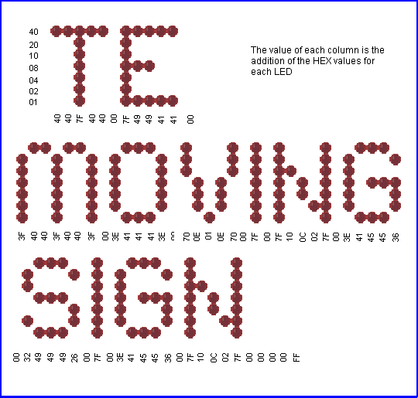
 | Experiment-12 for "5x7 Display" Project  RUNNING SIGN  ;Program for PIC16F84 and only F84 chip  ;Takes data from Table1 and runs it across the screen  Start ORG 0x00 ;This sets up the ports  BSF 03,5  MOVLW 00h  MOVWF 05h  MOVWF 06h  BCF 03,5  GOTO Run1  ;Table1 holds the hex values for each column of LEDs  Table1 ADDWF 02h,1 ;Add W to Program Counter  RETLW 00h  RETLW 40h  RETLW 40h  RETLW 7Fh  RETLW 40h  RETLW 40h  RETLW 00h  RETLW 7Fh  RETLW 49h  RETLW 49h  RETLW 41h  RETLW 41h  RETLW 00h  RETLW 3Fh  RETLW 40h  RETLW 3Fh  RETLW 40h  RETLW 3Fh  RETLW 00h  RETLW 3Eh  RETLW 41h  RETLW 41h  RETLW 41h  RETLW 3Eh  RETLW 00h  RETLW 70h  RETLW 0Eh  RETLW 01h  RETLW 0Eh  RETLW 70h  RETLW 00h  RETLW 7Fh  RETLW 00h  RETLW 7Fh  RETLW 10h  RETLW 0Ch  RETLW 02h  RETLW 7Fh  RETLW 00h  RETLW 3Eh  RETLW 41h  RETLW 45h  RETLW 45h  RETLW 36h  RETLW 00h  RETLW 32h  RETLW 49h  RETLW 49h  RETLW 49h  RETLW 26h  RETLW 00h  RETLW 7Fh  RETLW 00h  RETLW 3Eh  RETLW 41h  RETLW 45h  RETLW 45h  RETLW 36h  RETLW 00h  RETLW 7Fh  RETLW 10h  RETLW 0Ch  RETLW 02h  RETLW 7Fh  RETLW 00h  RETLW 00h  RETLW 00h  RETLW 00h  RETLW 0FFh  Run1 CLRF 11h ;Clear the Ghost locations ready for starting  CLRF 12h  CLRF 13h  CLRF 14h  CLRF 15h  MOVLW 00  MOVWF 19h ;File 19h is the jump value for table  Run2 MOVLW 40h  MOVWF 18h ;File 18h counts the number of scans  CALL Shift ; and controls the "run speed"  INCF 19h,1  MOVF 19h,0 ;Put jump value into W  CALL Table1  MOVWF 15h ;W contains table data - put it in 15h  XORLW 0FFh ;If table value is FF,  BTFSC 03,2 ; bit 2 of file 3 will be SET (=1)  GOTO Run1 ;Start Table1 again  Run3 DECFSZ 18h,1 ;Scan the display 40h times  GOTO Run4  GOTO Run2  Run4 CALL Scan  GOTO Run3  Scan BSF 05,1 ;Reset 4017  NOP  BCF 05,1  MOVF 11h,0 ;Output the data at the 5 Ghost  MOVWF 06h ; locations to the display  CALL DelD  MOVF 12h,0  MOVWF 06h  CALL DelD  MOVF 13h,0  MOVWF 06h  CALL DelD  MOVF 14h,0  MOVWF 06h  CALL DelD  MOVF 15h,0  MOVWF 06h  CALL DelD  RETURN  ;SHIFT moves the data one place to the left to give the "movement"  ; effect on the screen  Shift MOVF 12h,0 ;Move file 12h to W  MOVWF 11h ;Move W to file 11h  MOVF 13h,0 ;Move file 13h to W  MOVWF 12h ;Move W to file 12h  MOVF 14h,0 ;Move file 14h to W  MOVWF 13h ;Move W to file 13h  MOVF 15h,0 ;Move file 15h to W  MOVWF 14h ;Move W to file 14h  RETURN  DelD DECFSZ 1Bh,1 ;Delay for viewing the  GOTO DelD ; column of LEDs  MOVLW 00h  MOVWF 06  Clk BSF 05,0 ;Clock the 4017 to  NOP ; the next output  BCF 05,0  RETURN  END | 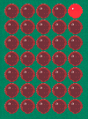

The block of numbers below is the HEX file for Experiment-12. Copy and paste it into a text program such as TEXTPAD or NOTEPAD and call it: Expt-12.hex

:10000000831600308500860083124C288207003456
:10001000403440347F344034403400347F344934F9
:1000200049344134413400343F3440343F34403467
:100030003F3400343E344134413441343E340034A2
:1000400070340E3401340E34703400347F34003494
:100050007F3410340C3402347F3400343E34413465
:100060004534453436340034323449344934493423
:10007000263400347F3400343E3441344534453432
:10008000363400347F3410340C3402347F3400347E
:10009000003400340034FF34910192019301940143
:1000A000950100309900403098007520990A190890
:1000B00006209500FF3A03194C28980B6028532816
:1000C00062205D28851400008510110886007E20BE
:1000D000120886007E20130886007E201408860001
:1000E0007E20150886007E20080012089100130863
:1000F0009200140893001508940008009B0B7E28BA
:0C01000000308600051400000510080007
:00000001FF

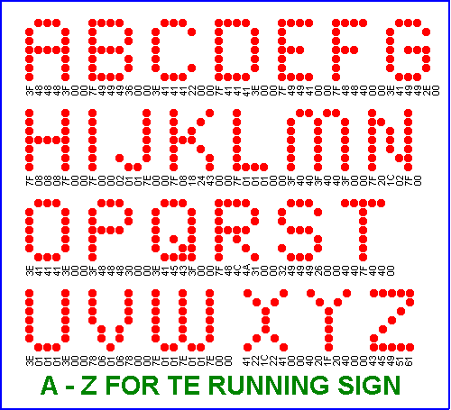
Send in your programs for inclusion on these pages.
Go to the next page of experiments: 5x7 EXPERIMENTS: Page-5

