This circuit will drive a 5 watt CFL tube from 6v or 12v.
Drive a CFL from 6v or 12v by Colin Mitchell
For this project you need an old Compact Fluorescent Lamp. Most faulty CFL’s are due to a dry-joint or dry electrolytic and the tube is perfect for re-cycling.
Only use a 5 watt Compact Fluorescent tube as each wattage tube puts a different load on the circuit and higher-wattage tube puts less load on the circuit and all the magnetic flux is not converted to energy. This saturates the core and overloads the transistor.
A high-wattage lamp will not be very bright and the transistor will get very hot.
You can also use an 18 watt (or 20 watt) 2-foot normal fluorescent tube.
You are only delivering 4 watts but it will be quite bright and will give much more light than a CFL.
The secret to getting the tubes to “strike” is the high voltage produced by the transformer.
The circuit is a “fly-back” design where the transistor is turned off during part of the cycle and the magnetic flux in the core of the transformer collapses and produces a very high voltage.
This high voltage passes through the gas in the tube and ionizes the gas molecules to create ultra-violet light. The phosphorescent coating on the inside of the tube converts the ultra-violet light to visible light.
Normally, small heaters at the end of the tube heat the gas and this creates “emissions” so a fairly low voltage (about 400v) will “strike the tube.”
We are not supplying energy to the heaters and we need over 1,000 volts to strike the tube - that’s why we have 500 turns on the secondary. Because the voltage is very high, we cannot wind the secondary as “jumble-wound.” You can wind it in layers with insulation between the layers but a simpler way is called PANCAKE winding.

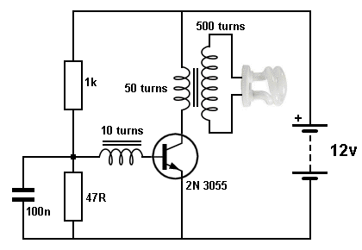
5 watt CFL Driver circuit

This consists of winding about 10 turns on top of each other before advancing along the rod. The rod can be round or flat, from an old AM radio. It is called a ferrite rod. See photo for size. The 500 turns have to be added before reaching the end and this means 100 turns has to take up 1/5th of the distance. This reduces the voltage between the turns as the enamel will only withstand 100 volts.
Before you start winding, use at least 3 layers of “sticky-tape” to prevent the high voltage shorting to the rod.
The size of the wire is not important and anything 0.25mm or thinner will be suitable. After winding the secondary, the primary is 50 turns and the feedback is 10 turns.
The primary can be 0.5mm wire and the feedback 0.25mm.
Connect the transistor, components and tube and turn the circuit ON very briefly. If the tube does not illuminate immediately, reverse the wires to the feedback winding.
The transistor must be 2N 3055 (or the plastic version, TIP 3055). It will get warm when illuminating the lamp and needs to be heatsinked. The lamp must not be removed as the circuit will overload and damage the transistor.
The circuit takes 250mA when driving a 5 watt CFL (or 18 watt fluorescent tube) on 12v supply. The 1k base resistor can be reduced to 820R and the brightness will increase slightly but the current will increase to 500mA.
The circuit is more-efficient on 6v. The 1k base resistor is reduced to 220R and the transistor remains cool.

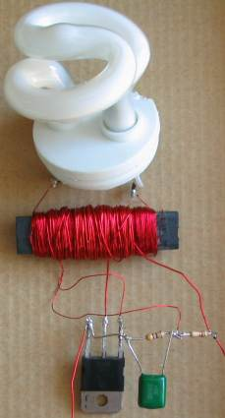

More details on this circuit can be found on the website: http://www.electronicsmaker.info

